Student Clustering and Major Prediction at the University of St. Thomas
May 2025
Introduction:
We examined student survey data collected from the University of St. Thomas (UST) in order to identify meaningful student profiles and try to identify/predict academic major selection for the incoming freshmen. The University of St. Thomas is a private Catholic institution in Minnesota. We used a dataset taken from surveys of incoming freshmen to understand how students differ in their motivations, values, and behaviors. This information is useful for the institution in planning student engagement and retention strategy, meaning decreasing the number of dropouts, and heighten the school's graduation rate.
The primary goals of this analysis were to (1) segment the student body into interpretable clusters based on survey responses. (2) Identify which student characteristics are the strongest predictors of a student’s chosen academic major. (3) Segment the student population into religious identity clusters. (4) Explore high school GPA by the first clusters. We achieved these goals by applying two main machine learning techniques aimed to identify patterns not seen through descriptive statistics.

Data, Context, and Preparation:
This dataset is a survey administered to incoming first-year freshmen students at UST. The source of this data is the Higher Education Research Institute at UCLA – CIRP Freshmen Survey. We used the incoming class of 2011 because it was one of the more recent options available as well as having survey questions that pertained more to our goals. The size of this class is 681 students, and the survey contained over 200 questions, which were a mix of behavioral, values, motivations, and self-rating questions. Before analysis, we had to recode the structured text responses into a numbered format for clustering. To accomplish our goals, we did trial and error of choosing different variable combinations to make the best clusters in terms of interpretation and separation. The following variables were selected that we deemed the best:
- RATE07 – Self-rating: Drive to achieve
- RATE17 – Self-rating: Spirituality
- GOAL07 – Goal: Being very well off financially
- GOAL09 – Goal: Making a theoretical contribution to science
- CHOOSE04 – College choice motivation: Academic reputation
- CHOOSE15 – College choice motivation: Religious affiliation/orientation
- HPW01 – Hours per week spent studying/doing homework
- HPW05 – Hours per week spent partying
- ACT01 – Past-year activity: Attended a religious service

Machine Learning Models Used:
In order to achieve our goals of segmenting the student body and predicting an academic major. We used two methods of machine learning: K-means clustering and decision trees.
K-means clustering was our primary tool to help us segment the student population into profiles. We ran our K-means clustering algorithm with four clusters and using our selected variables GOAL, RATE, CHOOSE, HPW, and ACT. We chose four clusters because it seems like a healthy amount to describe a student population. We ran a separate second algorithm with a focus on religious engagement using the variables: RATE17, CHOOSE15, and ACT01. One limitation to note was that K-mean's is sensitive to outliers, which were reflected in the small Party Outliers cluster that was formed due to a small sample size of extremely high party hours.
Decision trees were used alongside our dataset to address our second goal of predicting a student’s major. Decision trees learn from labeled outcomes; in our case, this was the student’s actual major. The decision tree would split students into more consistent groups based on the variables, with each split becoming increasingly more homogeneous than the previous. These splits also gave us insight into which variable was the strongest predictor for that specified major.

Results:
Our results consisted of multiple clusters where we used the average of each parallel coordinate plot to come up with the most accurate interpretations for each cluster. In these descriptions, we also included high school GPA and major choice information for specifics. The four-cluster k-means solution produced the following student profiles:
Cluster 1: Faith-Driven and Scholars (36.7%)
These students have the highest spirituality (4.14), highest drive (4.43), highest religious motivation for choosing UST (2.37), and the most study hours (7.97/week) all at once. They chose UST strongly for both academics (2.99) and religion (2.37). Party hours are low (1.21). Looking at the HSGPA mosaic, they have a strong A/A+ concentration (44% earned A or A+), confirming genuine academic strength. Their major distribution is broad but leans towards Professional, Business, and Biological Science; ambitious, mission-aligned fields. This is the quintessential UST student.
Cluster 2: Ambitious Students (41.5%)
These students have high drive (4.15) but the lowest spirituality (2.82), the highest financial goal (3.36), and the lowest religious motivation for choosing UST (1.23, lowest of all clusters). They chose UST almost entirely for academics (2.98, tied highest with C1). Study hours are moderate (5.06), party hours are low. Church attendance (1.32) is slightly higher than C1, but this is likely cultural habit rather than conviction given their low CHOOSE15. Their major mosaic shows the heaviest concentration in Business (44.83% of their column) and Engineering career-track fields. These students are at UST for the credential and career outcomes. They are the second-largest group and represent a significant portion of the student body that may be less connected to UST's Catholic identity.
Cluster 3: Disengaged Students (19.9%)
These students have the lowest academic reputation motivation (1.92, by far the lowest), the lowest financial ambition (2.73), low spirituality (3.61, middle), and moderate-low religious motivation (1.75). They study a moderate amount (6.31 hrs) but didn't really choose UST for any clear reason; neither academics nor religion drove their decision. Their HSGPA mosaic is the most B-heavy of any cluster, with far less A/A+ than C1 or C2. Major-wise, they spread across Education, Social Science, and Other Non-technical fields. These are students who may have chosen UST somewhat by default, with no strong pull toward the school's academic or religious mission. From a retention/persistence standpoint, these students are most likely not stay/do well.
Cluster 4: Party Outliers (1.9%)
This cluster contained only 13 students and was defined almost entirely by an extreme HPW05 value of 12.46 party hours per week, roughly 8 to 10 times higher than every other cluster. All other variable means for this group were close to the overall sample averages. This cluster seems to have emerged from K-Means sensitivity to outliers. Because K-Means minimizes within-cluster variance, a small group of students with extreme values on even one variable will be pulled into their own cluster to reduce overall distortion. With only 13 members, this group is too small to generalize any behavioral conclusions from, and we treat it as a statistical artifact rather than a true student profile.
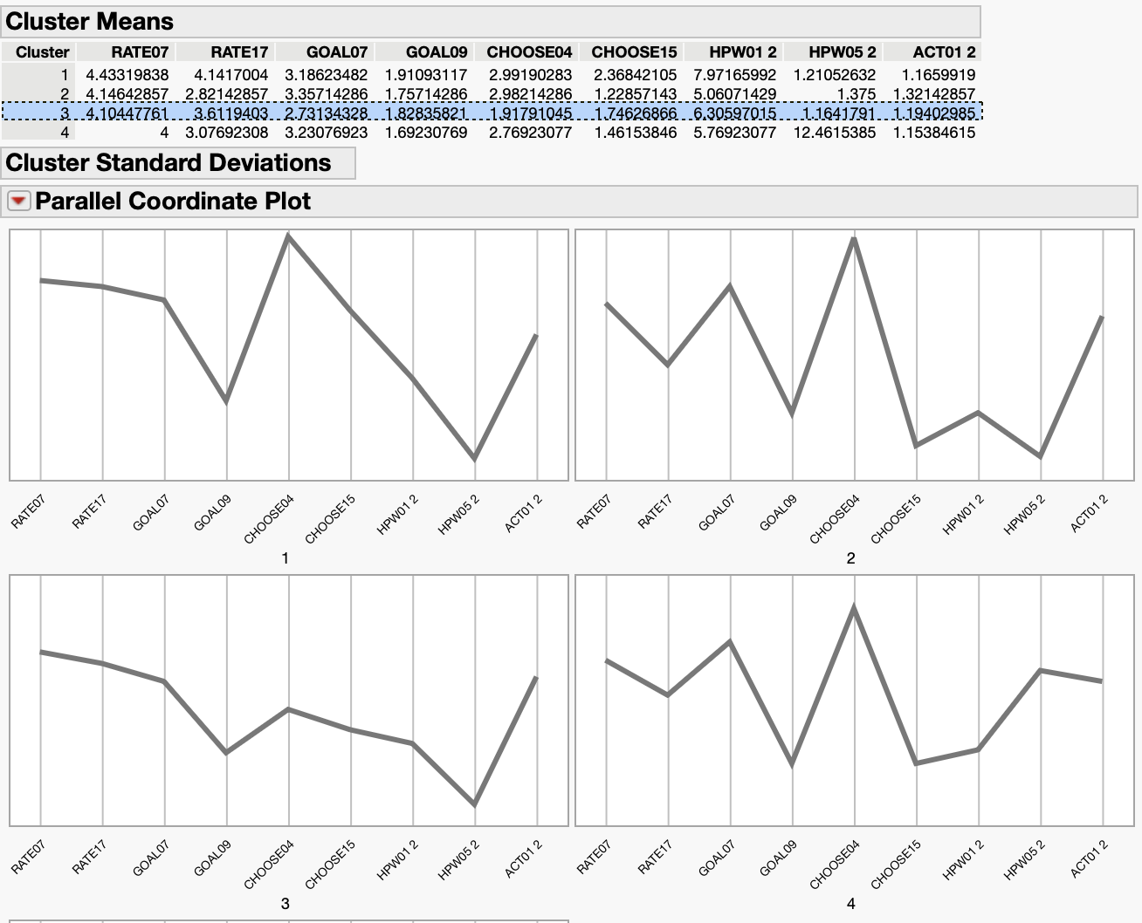
K-Means Clustering Parallel Coordinate Plots

High School GPA by Cluster:
High school GPA (HSGPA) distributions helped validate academic differences between the identified student clusters. The mosaic plots showed meaningful variation in prior academic performance across the groups.
Cluster 1, labeled Faith-Driven Scholars, demonstrated the strongest academic profile overall. Approximately 44% of students in this cluster earned an A or A+ high school GPA, the highest concentration among all clusters. This aligns closely with the cluster’s other characteristics, including the highest study hours per week, strongest academic motivation, and highest levels of drive and spirituality. These students appear highly achievement-oriented while also strongly connected to the university’s religious identity.
Cluster 2, labeled Ambitious Students, showed solid academic performance but slightly below Cluster 1. Around 29% of students earned an A or A+, while another large proportion earned A- grades. The distribution suggests academically capable students who are more career and financially motivated than mission driven. Their moderate study habits and concentration in business and engineering majors support this interpretation.
Cluster 3, labeled More-So Disengaged, displayed the weakest academic profile overall. While some students still earned high grades, the cluster had a noticeably larger concentration of B and B+ GPAs compared to Clusters 1 and 2. The mosaic plot appeared more “middle-heavy,” suggesting less consistent academic performance. Combined with their lower motivation for academics, religion, and financial success, this cluster may represent students with weaker institutional attachment and potentially greater retention risk.
Cluster 4, labeled Party Outliers, was too small to meaningfully interpret academically. The cluster was primarily created due to extremely high reported party hours.
Overall, the HSGPA results reinforced the broader clustering analysis. Students with stronger academic backgrounds were more likely to belong to clusters characterized by higher study hours, greater drive, and clearer educational or career goals.
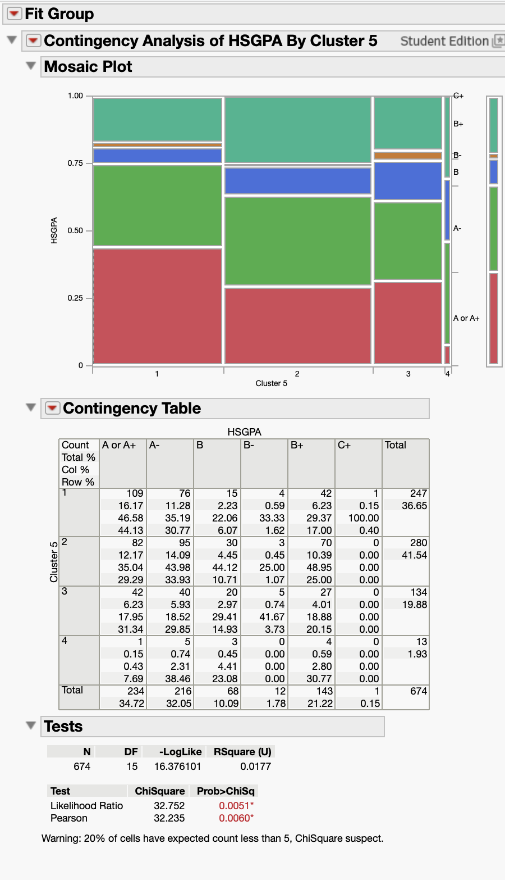
Contingency Table of HSGPA by Cluster
Major prediction by cluster:
Student major distributions provided additional insight into how academic interests and personal motivations differed across clusters.
Cluster 1 showed the strongest concentration in Health Professional majors, accounting for approximately 33.73% of students within that major category. This pattern is consistent with the cluster’s high levels of spirituality, academic achievement, and service-oriented goals. Biological Science and Business majors were also common, reflecting ambitious students pursuing academically demanding career paths while remaining connected to the university’s mission and values.
Cluster 2 was heavily concentrated in Business and Engineering majors. Business students made up approximately 44.83% of the cluster, while Engineering students represented another large share. These majors align closely with the cluster’s strong financial motivation and career-oriented mindset. Students in this group appeared primarily focused on academic reputation, credentials, and future earnings rather than religious affiliation or campus mission.
Cluster 3 was more concentrated in Education, Humanities, and Social Science majors. Education students accounted for approximately 22.58% of the cluster. Compared to the other groups, these students demonstrated lower financial ambition and weaker academic motivation. Their broader distribution across non-technical fields supports the interpretation that this cluster lacked a strong defining academic or institutional identity.
The major distributions support the broader clustering results by showing how students’ motivations, values, and academic priorities align with distinct educational pathways.
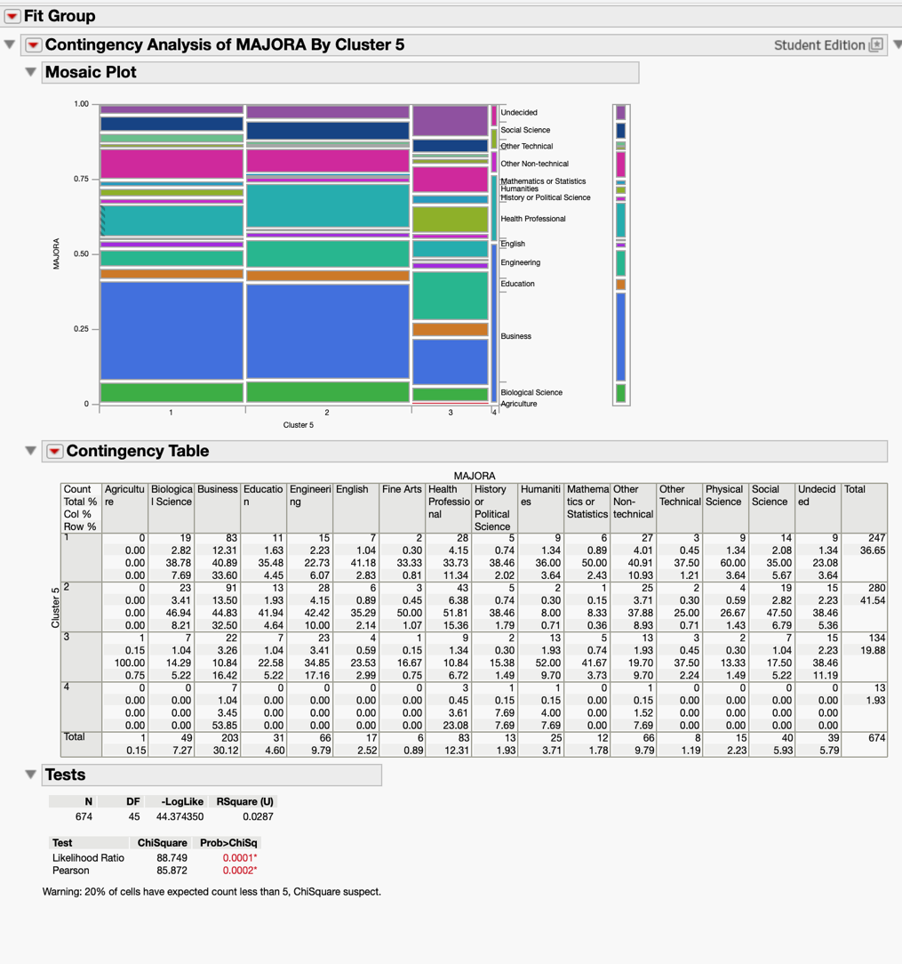
Contingency Table of MAJORA by Cluster

Classification trees:
The classification tree identified GOAL09 (making a theoretical contribution to science) as the most important predictor of a student’s academic major overall. The model produced an R-squared of 0.111, indicating that approximately 11% of the variation in major choice was explained by the selected variables, a modest but expected result given the complexity and personal nature of academic major selection. The decision logic produced by the tree can be summarized as follows: if a student strongly values contributing to science, they are likely pursuing a STEM or Health-related field. If a student does not prioritize science but places high value on financial success and is strongly driven, they are likely in Business. If a student places low emphasis on both science and financial goals, they are most likely in Education, Humanities, or Social Science.
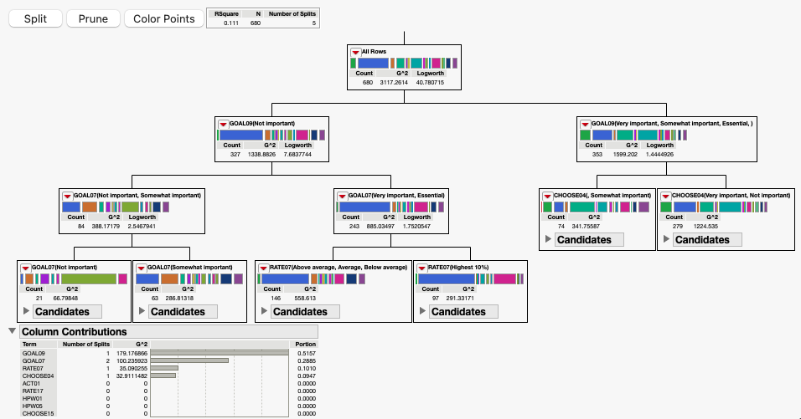
Decision Tree predicting MAJORA from the variables

Secondary Religious Engagement Clustering
Our other goal was to find the religious make-up of UST since it is a Catholic institution. We wanted to find how religious the students are by forming a secondary three-cluster analysis of religious engagement variables to produce three distinct faith profiles.
Cluster 1 - “Practicing Catholics” showed high church attendance (2.0) but only moderate religious motivation for choosing UST (1.31) and average spirituality (3.01). These students practice regularly, likely out of habit or upbringing, but faith was not a deliberate factor in their college decision.
Cluster 2 - “Secular Students” scored lowest on all religious measures, barely attending services (0.45), with the lowest spirituality (2.88) and near-zero religious motivation for college choice (1.03). Biplot output confirmed this cluster was the most heterogeneous.
Cluster 3 - “Intentionally Faith-Driven” had the highest spirituality (4.05) and by far the highest religious motivation for choosing UST (2.39), but only moderate church attendance (1.07), suggesting deeply personal faith expressed more privately than through formal service attendance. This cluster maps most closely onto Cluster 1 from the primary analysis.
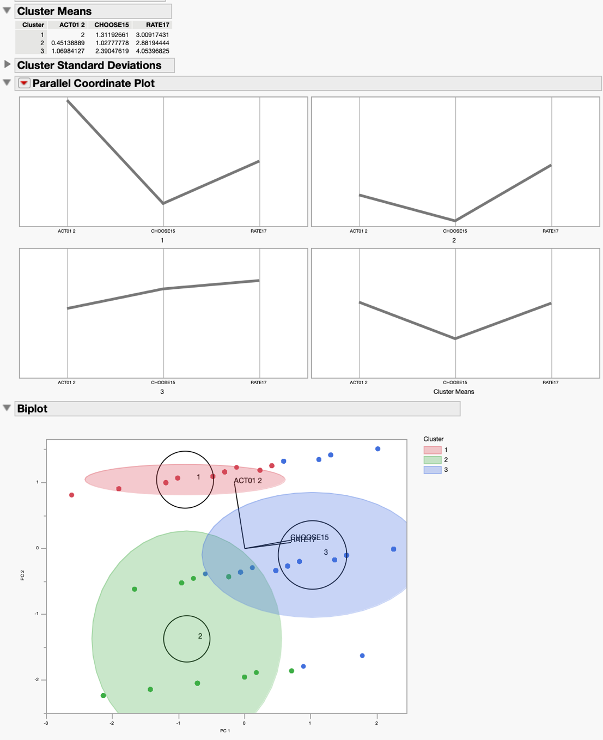
K-Means clustering of religious variables and Parallel Coordinate Plots

Conclusion:
Our research was set to segment the University of St. Thomas incoming freshmen class into profiles and identify the strongest predictors of academic major. Through our use of K-means clustering, we were able to find four profiles: Faith-Driven Scholars, Ambitious Students, Disengaged, and our small Party Outliers cluster. The groups were different in their survey responses as well as in their High School GPA and selected majors. We saw that our Faith-Driven Scholars leaned toward Health Professional fields, our Ambitious Students were more geared towards Business and Engineering fields, and our Disengaged group were focused on Education, Humanities, and Social Sciences.
Overall, our results showed that students arrive at UST during their freshmen year with very different motivations and priorities that tend to align with their distinct academic paths, which was expected. This research can help the University by reaching out to groups that are more at risk of dropping out, like the Disengaged students that may benefit from outreach and recurring advisement. Future work based on our research could help validate these profiles against the actual retention rates and graduation outcomes of the students.

